

|  |  |  |
| --- | --- | --- |
| **S.NO** | **TABLE OF CONTENTS** | **PH.NO** |
| 1. | ABSTRACT | 03 |
| 2. | INTRODUCTION | 04 |
| 3. | OBJECTIVES | 05 |
| 4. | UML DIAGRAM | 06 |
| 5. | KEY FEATURES | 07 |
| 6. | TECHNOLOGICAL STACK AND TEHNOLOGIES | 08 |
| 7. | CONCLUSION | 09 |

**ABSTRACT**

**ABSTRACT:**

The Advanced Attendance Management System revolutionizes the conventional attendance tracking process by introducing a user-friendly interface that facilitates easy login and registration. Users can seamlessly navigate through attendance records, leveraging efficient search options based on student names, class details, or dates. The system provides comprehensive information on each student's attendance status, empowering administrators to make informed decisions. Users can register and create profiles, enhancing their engagement with attendance data. Enriched with additional features such as attendance summaries, student profiles, and class details, the system encourages a deeper connection with attendance management. The admin login section ensures secure access for administrators, allowing them to generate various reports, from student attendance reports to class-wise summaries, utilizing analytics tools for data-driven decision-making. The inclusion of a Request Leave feature enables students to communicate absences, while the Announcements section facilitates seamless communication between administrators and users, keeping everyone informed about the latest attendance-related updates. This comprehensive approach aims to automate routine attendance tracking tasks, enabling educators and administrators to focus on strategic aspects of academic management. As we look ahead, future enhancements include a predictive attendance analysis system, a virtual class dashboard feature, and improved accessibility options, reflecting our commitment to evolving with the dynamic needs of educational institutions and their stakeholders.

**INTRODUCTION:**

Step into the future of Attendance Management with our state-of-the-art Attendance Management System. The journey begins at our welcoming homepage, where users are greeted with the options to either log in to their accounts or seamlessly register for a new one, creating a personalized and user-friendly environment. Distinguished by its user-centric design, our system prioritizes accessibility and ease of use.

A unique feature of our Attendance Management System is its restriction of admin access on the welcome page, ensuring that users experience a tailored interface distinct from administrative functions. This deliberate separation allows educators and students to engage seamlessly with attendance records without the complexities associated with administrative tasks.

This innovative system is engineered to significantly reduce manual efforts, ushering in an era of efficient attendance tracking. By leveraging cutting-edge technology, routine tasks are automated, allowing educators and users alike to dedicate more time to teaching and learning.

Searching for attendance records has never been more intuitive. Users can effortlessly find the desired information by utilizing search criteria such as student names, class details, or dates. This streamlined search functionality empowers users to navigate through attendance data with precision and ease.

In a nod to convenience, our Attendance Management System is equipped to display attendance information directly from the dashboard. This feature provides users with instant access to valuable information, making the exploration of attendance records a seamless and enriching experience.

**OBJECTIVES**

**User-Centric Interface:**

Create a welcoming homepage that prioritizes user experience with clear options for login and registration.

Restrict admin access on the welcome page to streamline user interactions and provide a focused interface for educators and students.

**Efficiency and Automation:**

Reduce manual efforts significantly by automating routine attendance tracking tasks.

Free up educator and user time for more meaningful engagement with teaching and learning.

**Streamlined Attendance Search:**

Enhance the search functionality to allow users to find attendance records effortlessly using student names, class details, or dates.

Provide a user-friendly interface that enables precise navigation through attendance data.

**Digital Content Accessibility:**

Enable users to access attendance information directly from the dashboard, ensuring swift engagement with valuable data.Foster a culture of data-driven decision-making by seamlessly integrating technology into the attendance management experience.

**Adaptability to Modern Educational Needs:**

Create a dynamic and efficient digital ecosystem that adapts to the evolving requirements of modern educational institutions.

UML DIAGRAM

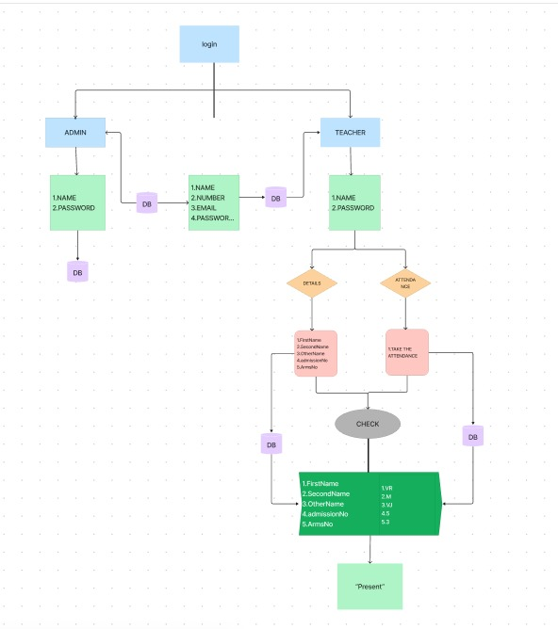

**KEY FEATURES**

**User-Friendly Interface:**

The system boasts an intuitive and easy-to-navigate interface, ensuring a seamless experience for both educators and students.

**Attendance Record Management:**

Efficiently manage and track attendance records, including details such as student names, class details, and dates.

**User Management:**

Maintain a centralized database of students, enabling educators to monitor attendance, track leave requests, and manage student profiles.

**Search and Retrieval:**

Implement a powerful search functionality allowing users to quickly locate attendance records based on various criteria, fostering an efficient browsing experience.

**Leave Request and Approval:**

Simplify the process of requesting and approving leave with automated tracking and notifications, reducing manual workload for educators.

**Reports and Analytics:**

Generate insightful reports on attendance trends, class-wise summaries, and student attendance history to aid decision-making and resource optimization.

**TECHNOLOGICAL STACK**

**Java:**

Leveraging the power of Java for backend development, ensuring robustness, scalability, and compatibility across different platforms.

**HTML:**

Employing HTML for creating a dynamic and responsive user interface, providing an engaging experience for users accessing the system from various devices.

**Servlet:**

Utilizing servlet technology to handle requests and responses, enabling seamless communication between the frontend and backend components of the system.

**MySQL:**

Implementing a relational database using MySQL to store attendance data securely and efficiently.

**Eclipse:**

Utilizing Eclipse as the development IDE for building and managing the system components.

**CONCLUSION:**

In conclusion, our Attendance Management System stands as a beacon of innovation and efficiency in the realm of academic administration. With a user-centric welcome page, streamlined attendance search functionalities, and direct access to attendance records, we have crafted a platform that redefines the attendance tracking experience for educators and students. By significantly reducing manual efforts through automation and fostering adaptability to modern educational needs, our system ensures a dynamic and efficient ecosystem.